**Question 01:**

**Create a new document Write the following paragraph along with its equation. You will find the equation and symbols in INSERT tab.**

**Answer:**

**3.1 Performance measures**

**Let {*Q1,…,Qq*} be the set of query images. For the *i-th* query *Qi,* let *I1(i) ,…,Qa1* are correct answers and *rank* (*Ij(i)*) is the rank of *Ij(i)* in the result. We use three performance measures [7]:**

$$(1)Avg-r=\frac{1}{q}\sum_{i=1}^{q}{\frac{1}{a_{i}}}\sum_{j=1}^{a_{i}}{rank\left(I_{j}^{\left(i\right)}\right).}$$

$$\left(2\right)Avg-p=\frac{1}{q}\sum_{i=1}^{q}{\frac{1}{a_{i}}}\sum_{j=1}^{a_{i}}{\frac{j}{rank(I_{j}^{(i)})}.}$$

**(3) *Recall vs. Scope*: For query *Qi* and scope *S(S>0):***

***Recall r = | {Ij(i)|* *rank (Ij(i)) ≤ S}* | / *ai.***

**Question 02:**

**Create a file named lab1.docx containing the following text. With the specified changes**

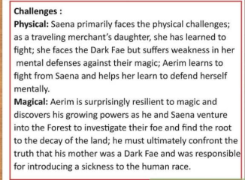

**a) Font color for every noun should be blue and for verb it should be green. b) Text in bold should be made italic also.**

**c) First paragraph should be in times new roman (10) and second should be in Arial (10).**

**d) Nouns Saena and aerim should be in “Blackadder ITC” font size 36.**

**Note: There should be no green blue or red lines under the text.**

**Answer:**

***Challenges:***

***Physical:* Saena primarily faces the physical challenges; as a travelling merchant’s daughter, she has learned to fight; she faces the Dark Fae but suffers weakness in her mental defenses against their magic; Aerim learns to fight from Saena and helps her learn to defend herself mentally.**

***Magical:* Aerin is surprisingly resilient to magic and discovers his growing powers as he and Saena venture into the Forest to investigate their foe and find the root to the decay of the land; he must ultimately confront the truth that his mother was a Dark Fae and was responsible for introducing a sickness to the human race.**

**Question 03:**

**Write an Article using sample template**

**a) Insert 5 lines drop cap at a distance of 0.3cm from text**

**b) Insert header with your name and page no**

**c) Set margins Mirrored**

**d) Landscape orientated, size Tabloid, justified.**

**e) Insert citation, Bibliography and footnotes where necessary**

**f) Insert related picture or table with caption**

**g) Proof read your document and add comments**

**Answer:**

This question is being left unanswered on the direction of Miss. Fizza, since this topic was not covered in the lab held on 26th September 2020.

**Question 04:**

**Create a sales Table.**

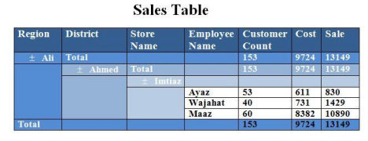

**Answer:**

**Sales Table**

|  |  |  |  |  |  |  |
| --- | --- | --- | --- | --- | --- | --- |
| **Region** | **District** | **Store**  **Name** | **Employee**  **Name** | **Customer**  **Count** | **Cost** | **Sale** |
| **± Ali** | **Total** |  |  | **153** | **9724** | **13149** |
|  | **± Ahmed** | **Total** |  | **153** | **9724** | **13149** |
|  | **± Imtiaz** |  |  |  |  |
|  | **Ayaz** | **53** | **611** | **830** |
| **Wajahat** | **40** | **731** | **1429** |
| **Maaz** | **60** | **8382** | **10890** |
| **Total** |  |  |  | **153** | **9724** | **13149** |

**Question 05:**

Create a document and give 5 Footnotes.

▪ Type the 3 Paragraphs of text and apply align left, align right, align justify. ▪ Assign bold, italic, underline for 3 Paragraphs, text background color different and give 3 different fonts for those.

▪ Write 4 different bookmark and use go to book mark options.

▪ Apply auto formatting on text the word is Pakistan.

**Answer:**

Most people fail to realize that in life, **it’s not how much money you make. It’s how much money you keep.** We’ve all heard stories of *lottery winners* who are poor, then suddenly rich, and the poor again. They win millions, yet are soon back where they started. Or stories of professional athletes, who at the age of 24 are earning millions, but are sleeping under the bridge 10 years later.

I remember a story of a young basketball player who a year ago had millions. Today, at just 29, he claims his friends, attorney and accountant took his money, and he was forced to work at a car wash at *minimum wage*. He was fired from the car wash because he refused to take off his championship ring as he as wiping off the cars. His story made national news and he is appealing his termination, claiming hardship and *discrimination*. He claims that the ring is all he has left and if it was stripped away, he’d *crumble*.

I know so many people who became instant *millionaires*. And while I am glad some people have become richer and richer, I caution them its not how much money you make it’s how much money you keep, and how many generations you keep it.

(Passage taken from “Rich Dad Poor Dad” by “Robert Kiyosaki”)

**Question 06:**

Create the document on any topic of your choice, add the picture and wrap the text

**Answer:**

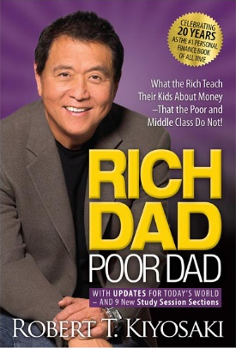One of my favorite books is “Rich dad Poor Dad” by “Robert T. Kiyosaki”. It is one of New York Times bestsellers of all time. In this book Robert sheds lights on his childhood where he grew among children of rich people while he himself was not very rich. He shares his story about how his childhood experiences led him to a very different and “UNCONVENTIONAL” path to financial freedom. He discusses about two different ideologies of his two dads. The first is his real father who is a high school teacher and the person whom Robert metaphorically calls his second father is his friend Mike’s dad. Mike’s Dad or the “Rich Dad” plays a key role in training and mentoring Robert thus helping him on his quest to financial freedom. In this book Robert shares valuable insights about various misconceptions about “money” and how people DEAL with it and how people SHOULD deal with. It is a great book and If anybody wants to pave the path of his financial freedom than this book must be his first step.